<Title of Your Report>
<Author names with academic degrees in this format: Jane Doe, MD, MPH¹,²>
AFFILIATIONS:
¹<Your department/division, facility/clinic, city, state, and country (if outside the United States)—for example, Surgical Outcomes Research Center, Department of Surgery, University of Washington, Seattle>

²<Your department/division, facility/clinic, city, state, and country (if outside the United States)>

Original Project Title: <Original title of report, if applicable>
PCORI ID: <PCORI ID>
HSRProj ID: <ID, if applicable>
ClinicalTrials.gov ID: <ID, if applicable>
_______________________________
To cite this document, please use: <PCORI to complete>

Table of Contents
ABSTRACT 4
BACKGROUND 5
<Type Your Heading 2 Text Here> 5
PARTICIPATION OF PATIENTS AND OTHER STAKEHOLDERS 6
METHODS 7
Study Overview 7
Study Setting 7
Participants 7
Interventions and Comparators or Controls 7
Study Outcomes 7
Covariates 7
Sample Size Calculations and Power 7
Time Frame for the Study 7
Data Collection and Sources 8
Analytical and Statistical Approaches 8
Changes to the Original Study Protocol 8
RESULTS 9
Allocation 10
Follow-Up 10
Analysis 10
Enrollment 10
DISCUSSION 11
Summary of Results 11
Results in Context 11
Potential to Affect Health Care Decision-Making 11
Lessons Learned 11
Generalizability 11
Subgroup Analyses/Heterogeneity of Treatment Effects 11
Study Limitations 11
Future Research 11
CONCLUSIONS 12
REFERENCES 13
RELATED PUBLICATIONS 14
ACKNOWLEDGMENTS 15
Data Sharing Plan 15
APPENDIX/APPENDICES 16
Appendix A. <Title of Appendix A> 16

Note: To update the Table of Contents, right-click it (Windows) or Control-click it (macOS), and then select Update Field. In the Update Table of Contents dialog box, select Update entire table, and then select OK. Do not enter or change page numbers or text manually.
Note: If you have notes that apply to the entire report (eg, sources for content that appears throughout the report), please list them here. If a note applies to a particular section, please insert the note at the beginning of that section.

ABSTRACT
Background: <Type your report background here>
Objective {or Objectives, if more than one}: <Type your specific aims here>
Methods: <Type your study methods here>
Results: <Type your study results here. Present numerical outcomes as the difference between groups and 95% confidence interval>
Conclusions: <Type your study conclusions here>
Limitations: <Type your study limitations here>
Note: This template contains all the paragraph styles you need to write your report. To access these styles:
- On a Windows PC, open Microsoft Word. On the Home tab of the ribbon, click the dialog box launch button at the bottom right of the Styles gallery to open the Styles Pane.
- On a Mac, open Word. On the Home tab of the ribbon, click Styles Pane.
In the Styles Pane, simply click the style you want to apply (e.g., Heading 1, Normal, Author List) and start typing.

BACKGROUND
<Type the background for your report.>

<Type Your Heading 2 Text Here>
<Type text beneath this heading.>

<Type Your Heading 3 Text Here>
<Type text beneath this heading.>
- <Level 1 bulleted list>
- <Level 2 bulleted list>
Type your heading 4 text here. <Type text after this heading.>
Type your heading 5 text here. <Type text after this heading.>
Note: The “Background” section must conclude with your study’s specific aims and hypotheses.

PARTICIPATION OF PATIENTS AND OTHER STAKEHOLDERS
<Type the text for this section of your report.>
Note: The “Participation of Patients and Other Stakeholders” section should describe how you identified, recruited, and retained stakeholders; the type and number of stakeholders involved; and the engagement activities that occurred or are ongoing. Describe and provide examples of how you obtained and considered patient and stakeholder feedback and how it influenced your study. If your study did not involve patients or stakeholder engagement, please explain why.

METHODS
<Describe the research strategy for addressing the identified methodological gaps under the subheadings below. For each subsection, you may simply refer to the Study Protocol or Research Plan, if applicable, with the text “See Study Protocol” or “See Research Plan”>

Research Design
<Summarize the research design (e.g., theory development, simulation studies, primary data collection, secondary data analyses).>

Data Sources and Data Sets
<Summarize the data sources and sets you used, including your justification for selecting a particular source or data-collection method.>

Analytical and Evaluative Approach
<Describe how the methods were evaluated, including outcome measures and investigation of underlying assumptions.>

Changes to the Original Study Protocol
<Summarize changes to the original study design. Confirm IRB (if applicable) and PCORI approval, and explain the reasons for the design modifications you were required to make or that became necessary during the study.>

RESULTS
<Type your results. You can access our table templates here. To use a table template, copy the template you need and paste it where you need it. You can then modify the table to meet your needs.>
Note: Please suppress line numbers for tables, table titles, notes, and legends. To suppress line numbers, select the desired lines in the report. On the ribbon, choose Layout, and then click the Line Numbers drop-down arrow. Select the Suppress for Current Paragraph option.>

Figure 1. <Type Descriptive Figure Title>
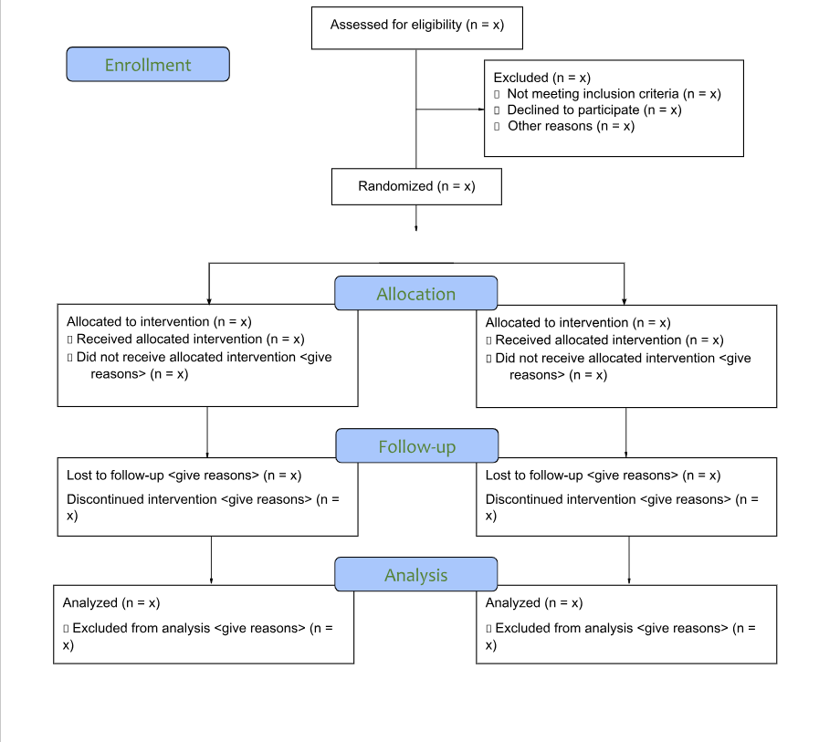
Participant Flow Diagram <To edit this figure, please use the template located here.>

DISCUSSION
<Type your study discussion under the following headings.>
Note: Required headings in this section are noted beneath the heading.

Summary of Results
<Summarize the results of your study.>

Results in Context
<Provide context for your study’s results.>

Potential to Affect Health Care Decision-Making
<Discuss your study’s potential to affect health care decision-making.>

Lessons Learned
<Describe the lessons learned from your study.>

Generalizability
<Discuss how/whether the results of your study can be generalized to different or larger populations.>

Subgroup Analyses/Heterogeneity of Treatment Effects
<Described the subgroup analyses/heterogeneity of treatment effects in your study. This is a required section.>

Study Limitations
<Describe the limitations of your study. This is a required section.>

Future Research
<Describe future research on this topic. This is a required section.>

CONCLUSIONS
<Type your conclusions.>

REFERENCES
Note: References should follow AMA Manual of Style, 11th edition, and be numbered according to the order in which they appear in the report body. Do not duplicate references. For further guidance, please refer to the Instructions for Awardee.
1. <Type reference>
2. <Type reference>

RELATED PUBLICATIONS
Note: This section is optional.
<List related publications.>

ACKNOWLEDGMENTS
Note: This section is optional.

Data Sharing Plan
Note: This section is optional.
<If you have a data sharing plan, explain when and where data will be available, the expected makeup of the datasets, and the approximate date of deposit per PCORI’s Policy for Data Management and Data Sharing. If you do not have a data sharing plan, please remove this entire “Data Sharing Plan” section.>

APPENDIX/APPENDICES

Appendix A. <Title of Appendix A>
Note Shells for tables are provided below. To use them, simply copy the shell you need and paste it into the Draft Final Research Report document. You may modify these table shells to meet your needs. If you need a landscape page to accommodate a larger table or figure, one is provided on the next page.

