
PATIENT-CENTERED OUTCOMES RESEARCH INSTITUTE
FINAL RESEARCH REPORT
<Title of Your Report>
<Author names with academic degrees in this format: Jane Doe, MD, MPH^{1,2}>
AFFILIATIONS:
¹<Your department/division, facility/clinic, city, state, and country (if outside the United States)—for example, Surgical Outcomes Research Center, Department of Surgery, University of Washington, Seattle>
²<Your department/division, facility/clinic, city, state, and country (if outside the United States)>
Original Project Title: <Original title of report, if applicable>
PCORI ID: <PCORI ID>
ClinicalTrials.gov ID: <ID, if applicable>
_______________________________
To cite this document, please use: <PCORI to complete>

Table of Contents
ABSTRACT 4
Overall BACKGROUND 5
<Type Your Heading 2 Text Here> 5
ENGAGEMENT OF PATIENTS, CAREGIVERS, AND OTHER HEALTHCARE DECISION MAKERS 6
AIM 1 7
Short Background/Introduction 7
Methods 7
Results 8
Discussion 9
AIM 2 10
Short Background/Introduction 10
Methods 10
Results 11
Discussion 11
OVERALL RESULTS 12
Overall DISCUSSION 14
Summary of Results 14
Results in Context 14
Potential to Affect Health Care Decision-Making 14
Lessons Learned 14
Generalizability 14
Subgroup Analyses/Heterogeneity of Treatment Effects 14
Study Limitations 14
Future Research 14
Overall CONCLUSIONS 15
REFERENCES 16
ACKNOWLEDGMENTS 17
PUBLICATIONS SUPPORTED BY PCORI AWARD 18
Data Sharing Plan 19
APPENDIX/APPENDICES 20

Template Instructions (To be deleted)
This template contains all the paragraph styles you need to write your report. To access these styles:
- On a Windows PC, open Microsoft Word. On the Home tab of the ribbon, click the dialog box launch button at the bottom right of the Styles gallery to open the Styles Pane.
- On a Mac, open Word. On the Home tab of the ribbon, click Styles Pane.
In the Styles Pane, click the style you want to apply (e.g., Heading 1, Normal, Author List) and start typing.
To update the Table of Contents, right-click it (Windows) or Control-click it (macOS), and then select Update Field. In the Update Table of Contents dialog box, select Update entire table, and then select OK. Do not enter or change page numbers or text manually.
If you have notes that apply to sources for content that appears throughout the report or a list of acronyms, please include that here. If a note applies to a particular section, please insert the note at the beginning of that section.

ABSTRACT
Background: <Type your report background here.>
Objective(s): <Type your specific aims here.>
Methods: <Type your study methods here.>
Results: <Type your study results here. Present numerical outcomes as the difference between groups and 95% confidence interval.>
Conclusions: <Type your study conclusions here.>
Limitations: <Type your study limitations here.>

Overall BACKGROUND
<Type the background for your report.>
Note: The “Background” section must conclude with your study’s specific aims and hypotheses.

<Type Your Heading 2 Text Here>
<Type text beneath this heading.>

<Type Your Heading 3 Text Here>
<Type text beneath this heading.>
- <Level 1 bulleted list>
- <Level 2 bulleted list>
Type your heading 4 text here. <Type text after this heading.>
Type your heading 5 text here. <Type text after this heading.>

ENGAGEMENT OF PATIENTS, CAREGIVERS, AND OTHER HEALTHCARE DECISION MAKERS
<Type the text for this section of your report.>
Note: The “Engagement of Patients, Caregivers, and Other Healthcare Decision Makers” section should describe how you identified, recruited, and retained patients and/or other community partners; the type and number of patients and/or other community partners involved; and the engagement activities that occurred or are ongoing. Describe and provide examples of how you obtained and considered patient and community partner feedback and how it influenced your study. Describe specific examples where input from the patient and community partners contributed to an element of the study and how feedback and contributions were obtained and considered. If your study did not involve patient or other healthcare decisionmaker engagement, please explain why.

AIM 1
Note: Brief descriptive titles must be included for each study aim. You can access our table templates here. To use a table template, copy the template you need and paste it where you need it. You can then modify the table to meet your needs. Please suppress line numbers for tables, table titles, notes, and legends. To suppress line numbers, select the desired lines in the report. On the ribbon, choose Layout, and then click the Line Numbers drop-down arrow. Select the Suppress for Current Paragraph option.

Short Background/Introduction
<Type a brief introduction to the Aim 1 section.>

Methods
<Type an introduction to the methods used in aim 1. Provide detailed information about your study methods based on the appropriate reporting guidelines for your study (see https://www.equator-network.org/). The headings below provide an outline for the DFRR. Use this outline as a framework for organizing your report.>

Overview
<Provide an overview of aim 1. Consider using a figure to illustrate complex interventions or overlapping study components.>

Setting
<Describe and justify the location(s) of aim 1.>

Participants
<For aim 1, provide recruitment, retention, and eligibility information for study participants. If the research includes clinic- or organizational-level outcomes, include a section that describes the recruitment and eligibility of those sites.>

Interventions and Comparators or Controls
<Provide sufficient detail to replicate the comparators of aim 1. Usual care should also be described in detail.>

Outcomes
<List the aim 1 outcomes, starting with the primary outcome(s), and how each will be measured.>

Covariates
<For aim 1, provide a list of covariates that were considered for adjusting analyses and justify the choices. Describe plans for subgroup analyses and the covariates used.> Sample Size Calculations and Power. Describe how the sample size was determined for Aim 1, including presenting power calculations and minimal clinically important differences for the outcomes.>

Study Procedures for Aim 1
<For aim 1, describe data collection methods, timeframe, and data sources. Describe the process of data collection and data storage, including efforts to maintain confidentiality. Detail the timeline for the study, including study start and end dates, recruitment periods, and follow-up periods. Consider using a Gantt chart to present the information. For randomized trials, include information about the randomization process and allocation concealment. Describe the data sources, including the measures used to measure the outcomes and covariates and how those measures were collected at each point.>

Analytical and Statistical Approaches
<Describe each component of data analysis for aim 1, including descriptive analyses, primary and secondary outcome analyses, and sensitivity or exploratory analyses. Include a section handling missing data and heterogeneity of treatment effects.>

Changes to the Original Study Protocol
<Summarize changes to the original study design. Confirm IRB (if applicable) and PCORI approval, and explain the reasons for the design modifications that the investigators were required to make or that became necessary during the study.>

Results
<Type your results for aim 1 here.>

Discussion
<Briefly summarize the discussion of aim 1 here. A discussion that pertains to the study as a whole should appear in the “Overall Discussion” section.>

AIM 2

Short Background/Introduction
<Type a brief introduction to the Aim 2 section.>
Note: If your report has more than 2 aims, duplicate this section as needed. Content in prior aims sections may be referenced to avoid repetition of information previously provided.

Methods
<Type an introduction to the methods used in aim 2. Provide detailed information about your study methods based on the appropriate reporting guidelines for your study (see https://www.equator-network.org/). The headings below provide an outline for the DFRR. Use this outline as a framework for organizing your report.>

Overview
<Provide an overview of aim 2. Consider using a figure to illustrate complex interventions or overlapping study components.>

Setting
<Describe and justify the location(s) of aim 2.>

Participants
<For aim 2, provide recruitment, retention, and eligibility information for study participants. If the research includes clinic- or organizational-level outcomes, include a section that describes the recruitment and eligibility of those sites.>

Interventions and Comparators or Controls
<Provide sufficient detail to replicate the comparators of aim 2. Usual care should also be described in detail.>

Outcomes
<List the aim 2 outcomes, starting with the primary outcome(s), and how each will be measured.>

Covariates
<For aim 2, provide a list of covariates that were considered for adjusting analyses and justify the choices. Describe plans for subgroup analyses and the covariates used.> Sample Size Calculations and Power. Describe how the sample size was determined for Aim 2, including presenting power calculations and minimal clinically important differences for the outcomes.>

Study Procedures for Aim 2
<For aim 2, describe data collection methods, timeframe, and data sources. Describe the process of data collection and data storage, including efforts to maintain confidentiality. Detail the timeline for the study, including study start and end dates, recruitment periods, and follow-up periods. Consider using a Gantt chart to present the information. For randomized trials, include information about the randomization process and allocation concealment. Describe the data sources, including the measures used to measure the outcomes and covariates and how those measures were collected at each point.>

Analytical and Statistical Approaches
<Describe each component of data analysis for aim 2, including descriptive analyses, primary and secondary outcome analyses, and sensitivity or exploratory analyses. Include a section handling missing data and heterogeneity of treatment effects.>

Changes to the Original Study Protocol
<Summarize changes to the original study design. Confirm IRB (if applicable) and PCORI approval, and explain the reasons for the design modifications that the investigators were required to make or that became necessary during the study.>

Results
<Type your results for aim 2 here.>

Discussion
<Briefly summarize the discussion of aim 2 here. A discussion that pertains to the study as a whole should appear in the “Overall Discussion” section.>

OVERALL RESULTS
Note: This section is optional. If you feel you have covered the results in each Aim section, you may omit this section. However, if you omit this section, please be sure to include the required Patient Flow Diagram in the results of your Aim 1 section above.

Figure 1. <Type Descriptive Figure Title>
Participant Flow Diagram <To edit this figure, please download the template located here.>

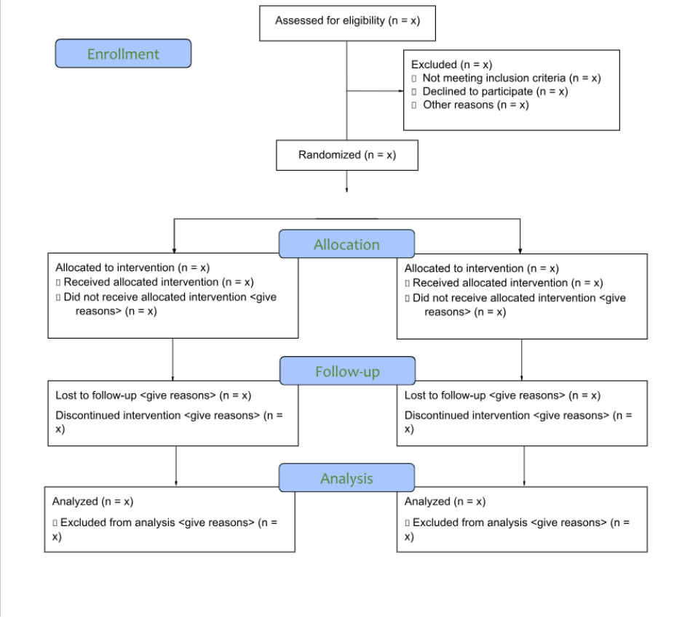

Overall DISCUSSION
<Type your study discussion under the following headings. Results must be integrated into this discussion.>
Note: Required headings in this section are noted beneath the heading.

Summary of Results
<Summarize the results of your study. This is a required section.>

Results in Context
<Summarize how your study contributes to the existing literature.>

Potential to Affect Health Care Decision-Making
<Discuss your study’s potential to affect health care decision-making, if applicable.>

Lessons Learned
<Describe any elements of the study design that might have been done differently or aspects of the study design that you found to be most important. The goal for this section is to help others prepare similar research or implement the interventions in this report.>

Generalizability
<Discuss how/whether the results of your study can be generalized to other sites and/or different or larger populations. This is a required section.>

Subgroup Analyses/Heterogeneity of Treatment Effects
<Describe the subgroup analyses/heterogeneity of treatment effects in your study. If you did not conduct subgroup analyses, please indicate that here. This is a required section.>

Study Limitations
<Describe the limitations of your study. This is a required section.>

Future Research
<Consider and describe future research on this topic. This is a required section.>

Overall CONCLUSIONS
<Type your conclusions. The conclusions should be half a page long and focus on high-level summary and results.>

REFERENCES
1. <Type reference>
2. <Type reference>
Note: References should follow AMA Manual of Style, 11th edition, and must be numbered according to the order of appearance in the text. Do not duplicate references. For further guidance, please refer to the Instructions for Awardee.

ACKNOWLEDGMENTS
Note: This section is optional.

PUBLICATIONS SUPPORTED BY PCORI AWARD
<List related publications.>
Note: This section is optional.

Data Sharing Plan
<If investigators have a data sharing plan, explain when and where data will be available, the expected makeup of the datasets, and the approximate date of deposit per PCORI’s Policy for Data Management and Data Sharing. If investigators do not have a data sharing plan, please remove this entire Data Sharing Plan section.>
Note: This section is optional.

APPENDIX/APPENDICES
Appendix A. <Title of Appendix A.>
Note: This section is optional. List the Appendices here. Upload them as a separate document(s) in the submission system.

