<Title of Your Report>
<Author names with academic degrees in this format: Jane Doe, MD, MPH¹,²>
AFFILIATIONS:
¹<Your department/division, facility/clinic, city, state, and country (if outside the United States)—for example, Surgical Outcomes Research Center, Department of Surgery, University of Washington, Seattle>

²<Your department/division, facility/clinic, city, state, and country (if outside the United States)>

Original Project Title: <Original title of report, if applicable>
PCORI ID: <PCORI ID>
ClinicalTrials.gov ID: <ID, if applicable>
_______________________________
To cite this document, please use: <PCORI to complete>

Table of Contents
ABSTRACT 4
BACKGROUND 5
<Type Your Heading 2 Text Here> 5
ENGAGEMENT OF PATIENTS, CAREGIVERS, AND OTHER HEALTHCARE DECISION MAKERS 6
METHODS 7
Study Overview 7
Study Setting 7
Participants 7
Interventions and Comparators or Controls 7
Study Outcomes 7
Covariates 8
Sample Size Calculations and Power 8
Study Procedures 8
Analytical and Statistical Approaches 8
Changes to the Original Study Protocol 8
RESULTS 9
DISCUSSION 11
Summary of Results 11
Results in Context 11
Potential to Affect Health Care Decision-Making 11
Lessons Learned 11
Generalizability 11
Subgroup Analyses/Heterogeneity of Treatment Effects 11
Study Limitations 11
Future Research 12
CONCLUSIONS 13
REFERENCES 14
ACKNOWLEDGMENTS 15
PUBLICATIONS SUPPORTED BY PCORI AWARD 16
Data Sharing Plan 17
APPENDIX/APPENDICES 18

Template Instructions (To be deleted)
This template contains all the paragraph styles you need to write your report. To access these styles:
- On a Windows PC, open Microsoft Word. On the Home tab of the ribbon, click the dialog box launch button at the bottom right of the Styles gallery to open the Styles Pane.
- On a Mac, open Word. On the Home tab of the ribbon, click Styles Pane.
In the Styles Pane, click the style you want to apply (e.g., Heading 1, Normal, Author List) and start typing.
To update the Table of Contents, right-click it (Windows) or Control-click it (macOS), and then select Update Field. In the Update Table of Contents dialog box, select Update entire table, and then select OK. Do not enter or change page numbers or text manually.
If you have notes that apply to sources for content that appears throughout the report or a list of acronyms, please include that here. If a note applies to a particular section, please insert the note at the beginning of that section.

ABSTRACT
Background: <Type your report background here.>
Objective(s): <Type your specific aims here.>
Methods: <Type your study methods here.>
Results: <Type your study results here. Present numerical outcomes as the difference between groups and 95% confidence interval.>
Conclusions: <Type your study conclusions here.>
Limitations: <Type your study limitations here.>

BACKGROUND
<Type the background for your report.>
Note: The “Background” section must conclude with your study’s specific aims and hypotheses.

<Type Your Heading 2 Text Here>
<Type text beneath this heading.>

<Type Your Heading 3 Text Here>
<Type text beneath this heading.>
- <Level 1 bulleted list>
- <Level 2 bulleted list>
Type your heading 4 text here. <Type text after this heading.>
Type your heading 5 text here. <Type text after this heading.>

ENGAGEMENT OF PATIENTS, CAREGIVERS, AND OTHER HEALTHCARE DECISION MAKERS
<Type the text for this section of your report.>
Note: The “Engagement of Patients, Caregivers, and Other Healthcare Decision Makers” section should describe how you identified, recruited, and retained patients and/or other community partners; the type and number of patients and/or other community partners involved; and the engagement activities that occurred or are ongoing. Describe and provide examples of how you obtained and considered patient and community partner feedback and how it influenced your study. Describe specific examples where input from the patient and community partners contributed to an element of the study and how feedback and contributions were obtained and considered. If your study did not involve patient or other healthcare decision maker engagement, please explain why.

METHODS
<Provide detailed information about your study methods based on the appropriate reporting guidelines for your study (see https://www.equator-network.org/). The headings below provide an outline for the DFRR. Use this outline as a framework for organizing your report.>
Note: You can access our table templates here. To use a table template, copy the template you need and paste it where you need it. You can then modify the table to meet your needs. Please suppress line numbers for tables, table titles, notes, and legends. To suppress line numbers, select the desired lines in the report. On the ribbon, choose Layout, and then click the Line Numbers drop-down arrow. Select the Suppress for Current Paragraph option.

Study Overview
<Provide an overview of the study design. Consider using a figure to illustrate complex interventions or overlapping study components.>

Study Setting
<Describe and justify the location(s) of the study.>

Participants
<Provide recruitment, retention, and eligibility information for study participants. If the research includes clinic- or organizational-level outcomes, include a section that describes the recruitment and eligibility of those sites.>

Interventions and Comparators or Controls
<Provide sufficient detail to replicate the comparators. Usual care should also be described in detail.>

Study Outcomes
<List the study outcomes, starting with the primary outcome(s), and how each will be measured.>

Covariates
<Provide a list of covariates that were considered for adjusting analyses and justify the choices. Describe plans for subgroup analyses and the covariates used.>

Sample Size Calculations and Power
<Describe how the sample size was determined, including presenting power calculations and minimal clinically important differences for the outcomes.>

Study Procedures
<Describe data collection methods, timeframe, and data sources. Describe the process of data collection and data storage, including efforts to maintain confidentiality. Detail the timeline for the study, including study start and end dates, recruitment periods, and follow-up periods. Consider using a Gantt chart to present the information. For randomized trials, include information about the randomization process and allocation concealment.>

Analytical and Statistical Approaches
<Describe each component of data analysis, including descriptive analyses, primary and secondary outcome analyses, and sensitivity or exploratory analyses. Include a section handling missing data and heterogeneity of treatment effects.>

Changes to the Original Study Protocol
<Summarize changes to the original study design. Confirm IRB (if applicable) and PCORI approval and explain the reasons or the design modifications that the investigators were required to make or that became necessary during the study.>

RESULTS
<Type your results.>
Note: Please refer to any standard reporting guidelines you followed and the CER outline in the Instructions for Awardee on our Author Resource site to organize your results section or determine what information should be included.

Figure 1. <Type Descriptive Figure Title>
Participant Flow Diagram <To edit this figure, please download the template located here.>
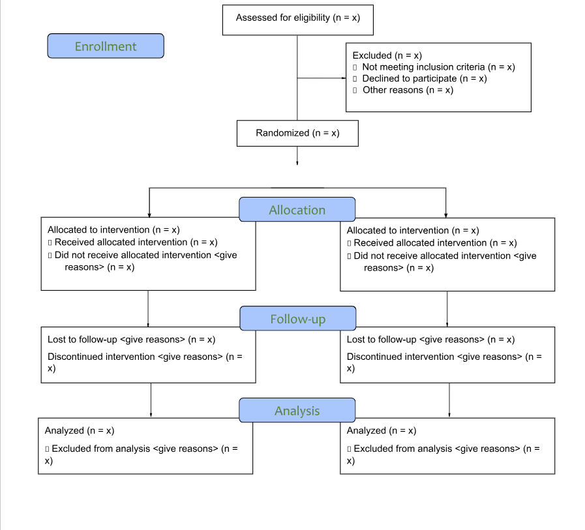

DISCUSSION
<Type your study discussion under the following headings.>
Note: Required headings in this section are noted beneath the heading.

Summary of Results
<Summarize the results of your study. This is a required section.>

Results in Context
<Summarize how your study contributes to the existing literature.>

Potential to Affect Health Care Decision-Making
<Discuss your study’s potential to affect health care decision-making, if applicable.>

Lessons Learned
<Describe any elements of the study design that might have been done differently or aspects of the study design that you found to be most important The goal for this section is to help others prepare similar research or implement the interventions in this report.>

Generalizability
<Discuss how/whether the results of your study can be generalized to other sites and/or different or larger populations. This is a required section.>

Subgroup Analyses/Heterogeneity of Treatment Effects
<Described the subgroup analyses/heterogeneity of treatment effects in your study. If you did not conduct subgroup analyses, please indicate that here. This is a required section.>

Study Limitations
<Describe the limitations of your study. This is a required section.>

Future Research
<Consider and describe future research on this topic. This is a required section.>

CONCLUSIONS
<Type your conclusions. The conclusions should be half a page long and focus on high-level summary and results.>

REFERENCES
1. <Type reference>
2. <Type reference>
Note: References should follow AMA Manual of Style, 11th edition, and be numbered according to the order in which they appear in the report body. Do not duplicate references. For further guidance, please refer to the Instructions for Awardee.

ACKNOWLEDGMENTS
Note: This section is optional.

PUBLICATIONS SUPPORTED BY PCORI AWARD
<List related publications.>
Note: This section is optional.

Data Sharing Plan
<If investigators have a data sharing plan, explain when and where data will be available, the expected makeup of the datasets, and the approximate date of deposit per PCORI’s Policy for Data Management and Data Sharing. If investigators do not have a data sharing plan, please remove this entire “Data Sharing Plan” section.>
Note: This section is optional.

APPENDIX/APPENDICES
Appendix A. <Title of Appendix A.>
Note: This section is optional. List the Appendices here. Upload them as a separate document(s) in the submission system.

